**Ideation Phase**

**Define the Problem Statements**

|  |  |
| --- | --- |
| Date | 17 October 2022 |
| Team ID | PNT2022TMIDxxxxxx |
| Project Name | Project – Emerging Methods for Early Detection of Foresting Fire |
| Maximum Marks | 2 Marks |

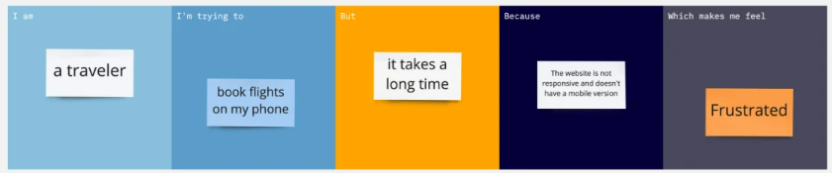

This causes reduction in the forest covers and overall increase in carbon di oxide and green house gases.

Spreading of particles form cigar remains also causes forest fires

Forest fire is caused due to negligently discarded cigarettes, and intentional acts of arson

To reduce the amount of carbon di oxide emission due to forest fires

Government

This causes reduction In the forest covers and overall increase in carbon di oxide and green house gases.

Forest fire is caused due to the burning of debris, equipment use and malfunctions

Government

To reduce the amount of forest cover destroyed due to forest fires

It is one of the major cause for forest fire

|  |  |  |  |  |  |
| --- | --- | --- | --- | --- | --- |
| **Problem Statement (PS)** | **I am (Customer)** | **I’m trying to** | **But** | **Because** | **Which makes me feel** |
| PS-1 | Government | To reduce the amount of forest cover destroyed due to forest fires | Forest fire is caused due to the burning of debris, equipment use and malfunctions | It is one of the major cause for forest fire | This causes reduction In the forest covers and overall increase in carbon di oxide and green house gases. |
| PS-2 | Government | To reduce the amount of carbon di oxide emission due to forest fires | Forest fire is caused due to negligently discarded cigarettes, and intentional acts of arson | Spreading of particles form cigar remains also causes forest fires | This causes reduction in the forest covers and overall increase in carbon di oxide and green house gases. |